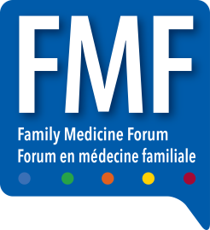

**FAMILY MEDICINE FORUM (FMF) 2025**

RBC Convention Centre, South Building Exhibit Halls ABC  
C/O Freeman  
375 York Ave  
Winnipeg, MB R3C 3J3  
Canada

**Company Name: _______________________**

Booth #: ________

No. _____ of _____ pieces

PLEASE DELIVER ON EXACTLY TUESDAY NOV 4th