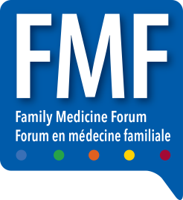

**FAMILY MEDICINE FORUM (FMF) 2025**

C/O Freeman  
61 Browns Line  
Toronto, ON M8W 3S2  
Canada

Company Name: _________________  
 Booth #: ________

No. _____ of _____ pieces

SHIP BETWEEN OCTOBER 6-22, 2025 TO ADVANCE WAREHOUSE