DISC Characteristics

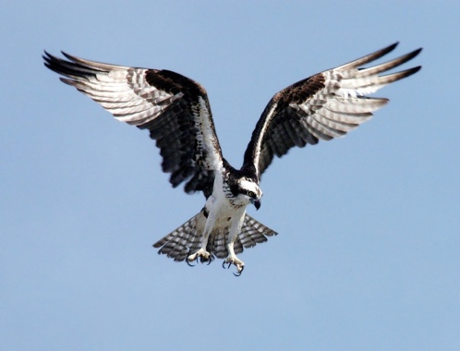
Dominance (D):
- Assertive: D-style individuals are direct and assert themselves confidently.
- Results-Oriented: They focus on achieving goals and driving outcomes.
- Decisive: They make decisions quickly and are often unafraid of taking risks.
- Competitive: D-style individuals thrive in competitive environments.
- Independent: They prefer autonomy and may excel in leadership roles.
- Problem-Solvers: They approach challenges with a solution-oriented mindset.
- Impatient: D-style individuals value efficiency and may become impatient with delays.
- Direct Communicators: They prefer clear, straightforward communication.

Influence (I):
- Sociable: I-style individuals are outgoing and enjoy social interactions.
- Enthusiastic: They bring energy and enthusiasm to their activities and relationships.
- Persuasive: They have strong persuasion and communication skills.
- Relationship-Oriented: Building and nurturing relationships is a priority for them.
- Optimistic: I-style individuals often maintain a positive and hopeful outlook.
- Expressive: They are comfortable expressing emotions and ideas openly.
- Collaborative: They thrive on teamwork and group activities.
- Creative: They have a creative and innovative approach to problem-solving.

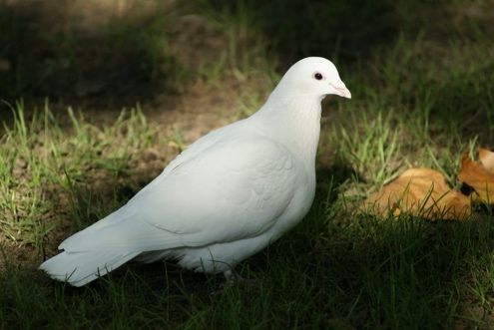
Steadiness (S):
- Patient: S-style individuals exhibit patience and a calm demeanor.
- Supportive: They are nurturing and provide emotional support to others.
- Team-Oriented: Building strong team cohesion is important to them.
- Reliable: S-style individuals are dependable and consistent.
- Non-Confrontational: They avoid conflicts and prioritize harmony.
- Good Listeners: They are attentive and empathetic listeners.
- Cautious: They prefer to take time and consider all options before making decisions.
- Detail-Oriented: They pay attention to details and maintain accuracy in tasks.

Conscientiousness (C):
- Analytical: C-style individuals possess strong analytical and critical thinking skills.
- Precise: They focus on accuracy and maintain high standards.
- Systematic: They prefer structured and organized approaches to tasks.
- Methodical: They are thorough and consider every detail before acting.
- Detail-Focused: C-style individuals have a strong attention to detail.
- Risk-Averse: They tend to be cautious and avoid unnecessary risks.
- Data-Driven: They rely on data and facts to support decisions and solutions.
- Self-Disciplined: They exhibit self-discipline and a strong work ethic.

Collaborating with Dominance (D) Style Team Members

Understanding Their Preferences:
- Be Direct: When communicating with D-style team members, remember they prefer direct and concise communication. Get to the point in your conversations.
- Clarity is Key: Use straightforward language and avoid overly complex or ambiguous messages to ensure clear understanding.
- Respect Autonomy: Acknowledge their need for independence and allow them to take the lead on tasks when appropriate.

Sensitivity to Their Fears:
- Autonomy Matters: To build a harmonious working relationship, avoid intruding on their domain or micromanaging their tasks, which can trigger concerns about losing control.
- Recognize Achievements: Show appreciation for their accomplishments to affirm their value and prevent feelings of undervaluation.
- Efficiency is Appreciated: Strive to streamline processes within the team to prevent frustration due to redundancy or inefficiency.

Enhancing Collaboration Through Communication:
- Clear Objectives: Set and communicate clear objectives and deadlines, providing a roadmap for successful collaboration.
- Challenging Assignments: Offer opportunities for them to take on significant responsibilities and tackle challenging tasks.
- Open Dialogue: Encourage open conversations and feedback to foster their active engagement and participation.

Supporting Under Stress:
- Recognize Stress Indicators: Pay attention to signs of impatience or irritability during stressful times. Offer empathy and understanding to help alleviate tension.
- Suggest Solutions: When they encounter challenges, provide assistance in identifying practical solutions. Offer your guidance for effective problem-solving.
- Recommend Short Breaks: During stressful moments, suggest they take short breaks to regain composure and maintain their productivity.
- Highlight Past Success: Remind them of their past accomplishments to boost their confidence when facing challenging situations.

Remember that these tips aim to create a productive and harmonious working relationship with D-style team members, even if you are not in a supervisory role. Applying these strategies can help improve collaboration and reduce potential conflicts within your team.

Collaborating with I-Style Team Members

Understanding Their Preferences:
- Be Sociable and Engaging
- Embrace Enthusiasm and Positivity
- Value Relationships and Social Interaction

Sensitivity to Their Fears:
- Acceptance and Inclusion are Vital
- Recognize Their Contributions to the Team
- Offer Recognition, Praise, and Encouragement

Enhancing Collaboration Through Communication:
- Foster Open Conversations and Brainstorming Sessions
- Encourage Creativity and Innovation
- Provide Opportunities for Social Interaction and Team-Building Activities

Supporting Under Stress:
- Recognize Stress Signals such as Overwhelm or Burnout
- Be Supportive and Positive, Offering Encouragement
- Encourage Short Breaks to Recharge
- Highlight Their Social Impact and Past Successes

Contributing to a Positive Team Environment:
- Capitalize on Their Charisma to Boost Morale
- Leverage Their Networking Skills for Team Connections
- Channel Their Energy into Motivation for the Team

Collaborating with S-Style Team Members

Understanding Their Preferences:
- Embrace Harmony and Stability
- Value Predictability and Consistency
- Foster Strong Team Relationships

Sensitivity to Their Fears:
- Acknowledge Their Need for Stability
- Recognize Their Dedication to the Team
- Offer Supportive and Reassuring Feedback

Enhancing Collaboration Through Communication:
- Foster Team Harmony and Cooperation
- Create a Supportive and Nurturing Environment
- Encourage Open Discussions and Inclusivity

Supporting Under Stress:
- Recognize Stress Signals, Such as Overwhelm or Resistance to Change
- Be Patient and Supportive
- Provide Opportunities for Relaxation and Stress Reduction
- Highlight Their Contributions to the Team's Stability and Consistency
Contributing to a Positive Team Environment:
- Capitalize on Their Consistency for Process Improvement
- Leverage Their Supportive Nature for Team Unity
- Channel Their Dedication into Reliable Team Results

Collaborating with C-Style Team Members

Understanding Their Preferences:
- Value Precision and Accuracy
- Prioritize Data and Analysis
- Embrace Structure and Order

Sensitivity to Their Fears:
- Recognize Their Need for Detailed Information
- Acknowledge Their Dedication to Quality Work
- Offer Constructive and Data-Driven Feedback

Enhancing Collaboration Through Communication:
- Emphasize Clear and Detailed Communication
- Encourage Methodical Problem-Solving
- Provide Opportunities for In-Depth Analysis and Planning

Supporting Under Stress:
- Recognize Stress Signals, Such as Perfectionism or Overthinking
- Be Patient and Provide Clear Guidelines
- Offer Time for Reflection and Decision-Making
- Highlight Their Contributions to Data Accuracy and Process Improvement

Contributing to a Positive Team Environment:
- Capitalize on Their Analytical Skills for Strategic Planning
- Leverage Their Structured Approach for Process Optimization
- Channel Their Dedication into High-Quality Team Results

