FMFC COI Mitigation & Non-Compliance Guidelines

APPROVED BY FMFC – MARCH 9, 2022
PART 1 - Review / Mitigation of COI
SUMMARY OF FMFC RESPONSIBILITIES
The FMFC is responsible for reviewing and mitigating bias in educational programs by:
- completing and submitting their own COI forms (yearly)
- reviewing COI declarations for all abstracts they wish to include and determine if it can be mitigated
- reject any where mitigation is not foreseeable, or assign follow up questions if warranted
- Important: FMFC to determine who is required to have the third slide and mandatory onsite review
- FMFC co-chairs or designate to follow up and determine if the conflict can be mitigated
- auditing these sessions onsite (virtual or live) to ensure full COI disclosure and compliance.

COI’s to be declared include any direct financial payments including receipt of honoraria; membership on advisory boards or speakers’ bureaus; funded grants or clinical trials; patents on a drug, product, or device; and all other investments or relationships that could be seen by a reasonable, well-informed participant as having the potential to influence the content of the educational activity.

BACKGROUND / ISSUES
Per the National Standard for support of Accredited CPD Activities, the Scientific Planning Committee (FMFC) must:
- be responsible for reviewing all disclosed financial relationships of speakers, moderators, facilitators, and authors in advance of the CPD activity to determine whether action is required to manage potential or real conflicts of interest. The SPC must also have procedures in place to be followed if a conflict of interest comes to its attention prior to or during the CPD activity (ref. 3.2 National Standard)

RECOMMENDATIONS
The following are steps to be followed by FMFC when reviewing/mitigating conflict of interest:
- Ensure conflict of interest information is collected from all submitters to the FMF Call for Abstracts
- Review all submitted COI information, flagging any concerns or questions for FMFC discussion
- For COI with insufficient information or questionable/concerning content, contact submitter for more information via C+E staff (conditional acceptance pending receipt of COI information)
- Discuss at scientific program planning section of FMFC meeting if flagged for further discussion
- Ensure that all accepted FMF speakers receive detailed speaker guidelines and instructions
- Ensure that all accepted FMF speakers receive COI slide templates (See Appendix A) and those with COI mitigation are instructed to use the 3rd slide in their presentation
- Remind speakers of the requirement to show and verbally acknowledge COI slides to the audience and allow questions

When declared COIs raise concern for FMFC members, the following steps should be taken to mitigate:
- FMFC co-chairs or designate to contact the presenter for additional COI information
- FMFC co-chairs to review the requested information
- If concern is still present, FMFC co-chairs or designate to contact the speaker to:
- Ensure they have reviewed and will adhere to all Mainpro+ and National Standards
- Ensure they will refrain from mentioning any brand names
- Ensure all content is evidence-based or indicate limited evidence exists
- Use only scientifically valid claims for all assertions made, refrain from personal opinion
- Reiterate the need to present and verbally disclose the COI slides (including slide 3)
- Reiterate the need to submit the COI forms and return these to the CFPC
- If required, a few additional inquires many be made:
- How were the topics and the presenter/facilitator/author determined?
- Will the speaker be making clinical recommendations?
- What sources of evidence will support the presentation?
- In some cases, the presenter may be required to submit their entire slide deck for review

The FMFC Co-chairs reserve the right to cancel a session based on incomplete COI information and/or concern that the bias cannot be mitigated.

Once FMFC agrees the COI has been sufficiently mitigated:
- A mitigation slide will be sent to each presenter to include in their presentation on behalf of FMFC
- For each session where bias has been mitigated by the FMFC, speaker to show slide this slide in addition to the standard slides required for all FMF presentations.

Additional FMFC Resources for Mitigating COI:
- QuickTips_COI_Final_ENGLISH.pdf
- The National Standard – Section 3 describes the Scientific Planning Committees COI requirements
- Conflict_of_Interest_Form
- CFPC Commonly_Referenced_Resources_and_Policy_Updates
- January 2020 – Webinar training for FMFC re: COI identification and management/mitigation

PART 2 – FMF Speaker Non-Compliance
KEY TOPIC
Process for FMF speakers who are not in compliance with the National Standard.

BACKGROUND / ISSUES
Per the National Standard for support of Accredited CPD Activities, the Scientific Planning Committee (FMFC) must:
- have a process in place to deal with instances where CPD activities are not in compliance with the Standard (ref. 2.4 National Standard).

RECOMMENDATIONS
The following procedures will be taken by FMFC to discover and follow up with non-compliant presenters

During FMF:
- FMFC will perform mandatory audits of all sessions selected for review during the mitigation process
- FMFC will perform mandatory audit of all ancillary sessions
- FMFC will also perform random audits of all other FMF certified activities
- The CFPC’s CPD department may also independently audit FMF sessions
- Attendees will have the opportunity to submit feedback on ALL sessions via online evaluation

Post-FMF:
- Session evaluation and audit data will be reviewed by FMFC and the CPD department
- Presenters identified during audit or from evaluation data as having violated Mainpro+ or National Standards will be reviewed by CPD and FMFC
- All session evaluation details, comments and COI infractions will be provided to the presenter and recorded by the FMFC for future reference
- In the event that a violation is identified by FMFC or CPD the following steps will be considered:
- In addition to any steps taken by the CPD Department (see Appendix B for full CFPC policy)

- For First Violations
- Notify the presenter(s) and provide details of the violation that occurred as well as reminders of Mainpro+ and National Standard

- For Repeat Violations or Violations deemed Major by the FMFC OR CPD department
- Enact First Violation Policy
- Share details of the violation and presenter information with all CFPC Chapter Offices
- Require mandatory audit of all future presentations involving a presenter for a period of years determined by the FMFC
- AND/OR impose a ban on future presentations at FMF by a presenter for a period of years determined by the FMFC
- OR no longer accept applications by a presenter to present at FMF

- Presenters may submit an appeal to the FMFC should a penalty be enforced in the form of a letter or similar correspondence which includes acknowledgement of their violation(s) and an explanation of why the violation(s) took place. Their understanding of Mainpro+ and national standards must be demonstrated, and a detailed outline of what steps will be taken to prevent future violations must be provided.
- Such appeals will be considered on a case-by-case basis by the FMFC AND CPD department.

MOTION: That the FMFC approve FMFC COI Mitigation & Non- Compliance Guidelines

MOVED : Dr. Amanda Tzenov SECONDED: Dr. Lana Barkhouse
CARRIED. Approved – All in favour

Appendix A – COI SLIDE TEMPLATES
Standard COI Slide #1
Faculty/Presenter Disclosure
- Faculty: [Speaker’s name]
- Relationships with financial sponsors:
  - Grants/Research Support: Pharma Corp ABC
  - Speakers Bureau/Honoraria: XYZ Biopharmaceuticals Ltd.
  - Consulting Fees: MedX Group Inc.
  - Patents: Widget ABC
  - Other: Employee of XXY Hospital Group

Standard COI Slide #2
Disclosure of Financial Support
- This program has received financial support from [organization name] in the form of [describe support here – e.g., an educational grant].
- This program has received in-kind support from [organization name] in the form of [describe support here – e.g., logistical support].
- Potential for conflict(s) of interest:
  - [Speaker/Faculty name] has received [payment/funding, etc.] from [organization supporting this program AND/OR organization whose product(s) are being discussed in this program].
  - [Supporting organization name] [developed/licenses/distributes/benefits from the sale of, etc.] a product that will be discussed in this program

COI Slide #3- Additional Slide if COI has been mitigated by FMFC
Mitigating Potential Bias
The FMF Committee has mitigated the potential bias for this presentation as follows:
- Presenter agrees to adhere to all Mainpro+ and National Standards
- Presenter has received the COI Quick Tips document
- Presenter agrees to present only evidence-based content or declare otherwise
- Presenter advised to use generic names only when discussing therapeutic options
Presenter agrees to include COI slides and verbal mention in each presentation

This Draft Mitigation slide that will be provided to all presenters FMFC has identified as having COIs that can be mitigated by insuring they receive this slide and all related documents and agree to follow all guidelines as outlined below:

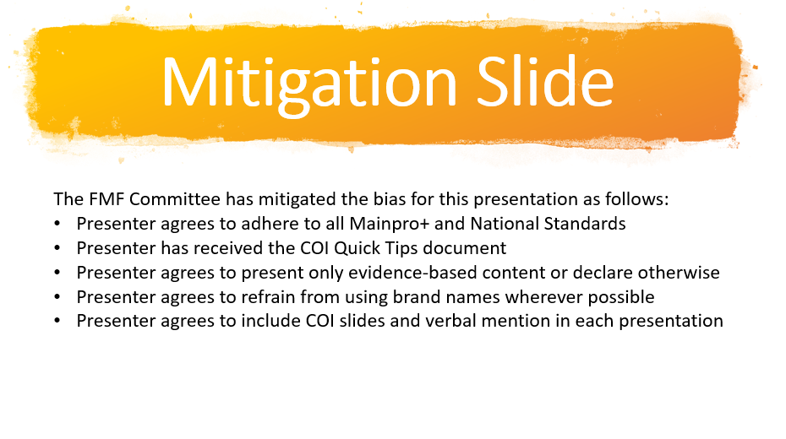

APPENDIX B – CFPC NON-COMPLIANCE POLICY
Addressing Mainpro+ certification policy or procedure violations
(excerpt from Mainpro+ Guidelines)

If in the course of delivering a Mainpro+ certified activity a continuing professional development (CPD) provider (individual and/or company) or speaker acting on behalf of a CPD Provider is found to be in violation of the College of Family Physicians of Canada (CFPC)’s standards for Mainpro+ certification—the standards and requirements outlined in this document, including the appropriate use of the Mainpro+ certification statement—the following process may apply.

First violation
- A written warning will be issued by the CFPC National Office. The CPD provider must provide evidence of amendments to any erroneous information and respond to the warning with details of how the individual or company has taken or will take steps to ensure compliance with Mainpro+ standards within 10 business days following receipt of the warning.
- Failure on the part of the CPD provider to provide evidence of amendments, institute corrective action, and/or respond to the warning within the time frame of 10 business days may result in “second violation” actions being employed.
- In instances where the violation is deemed to be significant in nature, the CFPC reserves the right to handle the violation as a second violation—vide infra—irrespective of whether a first violation has occurred.
- Also, if the violation is deemed to be significant in nature, the CFPC reserves the right to communicate the violation to Innovative Medicines Canada at any stage of the process.

Second violation
- A written warning will be issued by the CFPC National Office. A copy of this warning will be distributed to all CFPC provincial Chapter Offices and members of the National Committee on Continuing Professional Development (NCCPD). Within 10 business days of receipt of the warning, the CPD provider must provide evidence of amendments to any erroneous information and respond to the warning with details of how the individual and/or company has or will put into place measures to ensure compliance with Mainpro+ standards.
- Failure on the part of the CPD provider to provide evidence of amendments, institute corrective action, and/or respond to the warning within the 10-business-day time frame may result in

Subsequent violations
A referral will be made to the NCCPD for appropriate action, which may include but not be limited to one or more of the following:
- Revoking the certification of one or more programs (programs from the provider that are involved in “subsequent violations”) currently certified for Mainpro+ credits (CFPC members would not be permitted to claim Mainpro+ credits for their participation)
- A six- to 12-month suspension, during which time no new programs may be submitted for Mainpro+ certification/recertification
- A written complaint submitted to Innovative Medicines Canada in instances where the CPD provider is a member organization and it is believed that they have violated the Innovative Medicines Canada 2016 Code of Ethical Practices
- A written complaint submitted to the Federal Medical Regulatory Authorities and/or provincial licensing bodies where the CPD provider is a CFPC member or Non-Member Mainpro+ Participant and it is believed that they have violated standards related to professional conduct
- The rights of the CFPC pursuant to these standards and the actions set out herein are without prejudice to any other rights that the CFPC may have at law or otherwise.

Often, the CPD provider is a communications or consulting company acting on behalf of another organization or company; in such instances, both the contracted party (i.e., the communications company) and the contractor (i.e., the company or organization that engaged the contracted party) are considered to be the CPD provider. As such, when a violation is noted, both parties will be issued warnings and subject to appropriate action(s).

