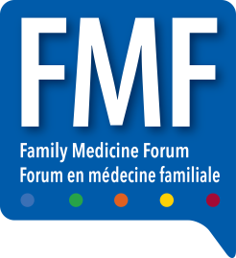

FAMILY MEDICINE FORUM 2022
METRO TORONTO CONVENTION CENTRE
SOUTH BUILDING
222 BREMNER BLVD
Toronto, Ontario, M5V 3L9
HALL E LOADING DOCK
DELIVER TO: Exhibit Hall Booth # ____________
COMPANY NAME: _______________________

PLEASE DELIVER ON EXACTLY TUESDAY NOV 8th

