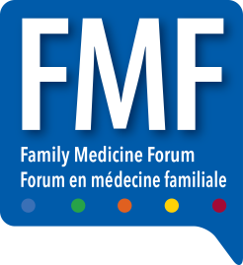

FAMILY MEDICINE FORUM 2022
ADVANCE WAREHOUSE SHIPPING
C/O FREEMAN
61 BROWNS LINE
Toronto, Ontario, M8W 3S2

DELIVER TO: Exhibit Hall Booth # ____________
COMPANY NAME: _______________________

