Canada’s largest family medicine conference goes virtual!
(August 25, 2020, Mississauga, ON) The College of Family Physicians of Canada’s (CFPC) flagship conference—Family Medicine Forum (FMF)—is moving to a virtual format this year. The conference will take place from November 4 to 7, 2020, and will welcome family physicians, teachers, researchers, residents, and medical students from across the country. The CFPC is pleased to offer four days of engaging sessions, virtual networking, online exhibits, and posters and a wealth of inspirational content throughout the event. FMF will also feature a lineup of impressive keynote speakers from around the globe.

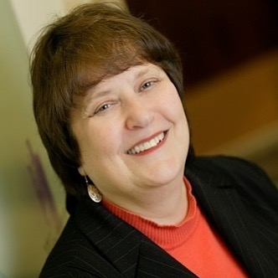
Dr. Carol Herbert’s keynote address, “How Should Evidence Change Practice: Choice, policy, or crisis?” will dig deep into the lags of incorporating new evidence into practice and uncover how we can pivot and become nimbler in our ever-changing world.

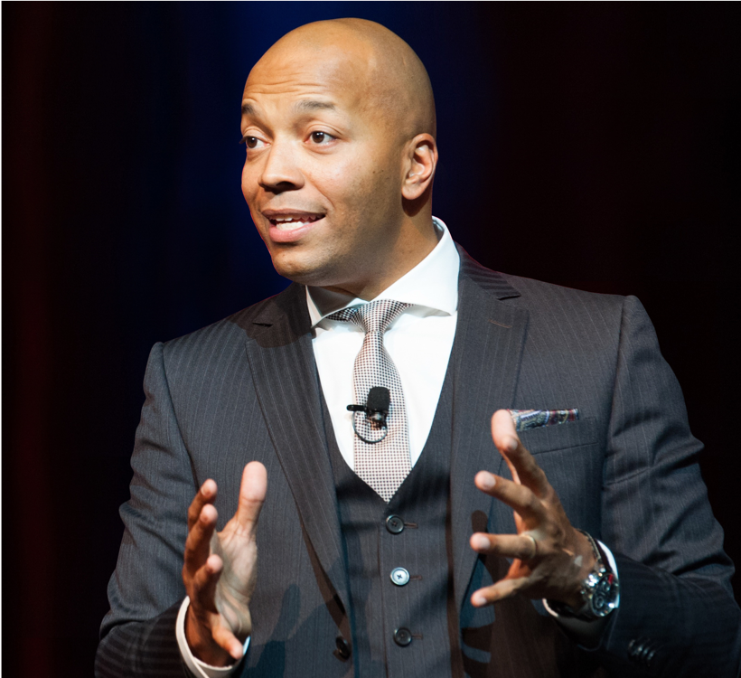
Stephan Maighan, a renowned motivational speaker, entrepreneur, and author, will reaffirm the notion that extraordinary times call for extraordinary people. He will tackle tough issues and help inspire greatness in a year when we need it the most!

Dr. Iona Heath, a family doctor from the United Kingdom and the recipient of the CFPC’s 2020 TD Insurance Spotlight on Achievement Award, will explore the challenges family medicine has faced during the COVID-19 pandemic in her keynote, “2020: The year of practising dangerously.”

“As the CFPC pivots to deliver FMF virtually, we will continue to offer all the high-quality continuing professional development opportunities and benefits attendees have come to expect, with the added benefit of attending from the comfort of your home or office,” says Jennifer Campbell, Director, CFPC Conferences and Events. “We are also thrilled to offer virtual concierge services throughout the event to ensure all participants have a seamless experience.”
The top 10 reasons to register for this year’s virtual FMF are:
- Diverse education: Live streaming of up to 80 clinical, teaching, and research sessions
- Vetted content: Evidence-based, peer-reviewed sessions and workshops
- Expert delivery: Cutting-edge cloud technology ensures easy connectivity from any device
- Interactivity: Sessions allow questions via live chats where applicable
- Community: Opportunities to share photos, bios, have one-on-one chats and meetings
- Virtual exhibitors: Products, tools, and resources to review and explore
- E-posters: A trail-blazing virtual gallery of posters on clinical, teaching, and research topics
- Networking: Opportunities for family medicine professionals to connect and collaborate
- Flexibility: Shorter days to accommodate time zones and sessions available for 30 days after FMF
- Special events: All special celebrations of achievements in family medicine are free this year
Dr. Peter Zhang, the FMF Committee’s resident representative, says he looks forward to “connecting with friends and mentors at the award celebrations, acquiring pro tips from First Five Years in Family Practice Committee members, and sharing some practice tips with medical students across the country, as previous residents have done for me.”

Scotiabank and MD Financial Management Inc. are proud to support the College of Family Physicians of Canada and Family Medicine Forum. FMF helps Canadian family physicians advance professionally and be recognized for their excellence in family medicine through awards and scholarships given to students and residents.
Keep up to date at https://fmf.cfpc.ca/ and follow us on social media using the hashtags #myfmf and #monfmf.
Twitter: https://twitter.com/FamilyMedForum
Facebook: https://www.facebook.com/FamilyMedicineForum
Instagram: https://www.instagram.com/familymedforum
YouTube: https://www.youtube.com/user/CFPCMedia
About the College of Family Physicians of Canada
The College of Family Physicians of Canada (CFPC) is the professional organization that represents more than 40,000 members across the country. The College establishes the standards for and accredits postgraduate family medicine training in Canada’s 17 medical schools. It reviews and certifies continuing professional development programs and materials that enable family physicians to meet certification and licensing requirements. The CFPC provides high-quality services, supports family medicine teaching and research, and advocates on behalf of the specialty of family medicine, family physicians, and the patients they serve.
-30-
Event contact:
Jennifer Campbell, Director, Conferences and Events
College of Family Physicians of Canada
905-464-5722 | jcampbell@cfpc.ca
Media contact:
Jayne Johnston, Director, Communications
College of Family Physicians of Canada
905-629-0900 ext. 303 | jjn@cfpc.ca

