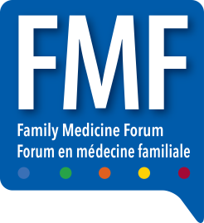
FAMILY MEDICINE FORUM 2018
METRO TORONTO CONVENTION CENTRE- SOUTH BUILDING – HALL D
222 BREMNER BLVD
TORONTO, ONTARIO, M5V 3L9
SHIPMENTS ACCEPTED FROM TUES. NOV 12 to SAT NOV 17, 2018
Exhibit Name: _____________________
Contact Person: ___________________
Booth #: ______ Cell Phone: _________

